Epsom & Ewell
11
v
British Airways
Saturday, 11th January 2020 – 3.00 p.m.
Happy New Year! Good afternoon and welcome to High Road for our latest Combined Counties League match against British Airways. They last visited us in February when we edged them out by three goals to two, after we had lost by the same score at The Orchard back in October 2018. We welcome their players, supporters and the match officials and hope they have a safe journey home.

Firstly, apologies for the reduced programme size and the fact that it is slightly out of date. I am away at present and had to get it completed on the previous Saturday!

You will of course be aware by now that we were taking applications for the post of Manager and I can advise that we had around 40 separate applications to Manage our club. The Committee are in the process of whittling down the numbers and will be in the process of conducting interviews shortly, if indeed we have not started already. As soon as we have more information on this, we’ll let you know!

We were last here two weeks ago for our 3-2 win over Westside which in the end flattered them a little. We did take our time to get going though and will not be afforded that time today either against a team that are a very good attacking unit.

Following today’s match we are scheduled to make the journey to Chessington & Hook United on Tuesday and to AFC Hayes next Saturday. Both however are very much subject to weather conditions having suffered a number of postponements this season already. We then return here for three matches in seven days against Kensington & Ealing on Tuesday 21st January, Cove on Saturday 25th January and Sandhurst Town on Tuesday 28th January. Additionally, our Surrey Premier Cup Second Round tie at home to Nottsborough has now been arranged and will take place on Tuesday 4th February.

Enjoy the game!

Rich

You can follow us on social media – just see the inside cover for details.

Cover photo

Here is a picture of our greatest moment of the decade as Jamie Hatfield lifted the Combined Counties League Cup in 2013, but how many of this team would make our Team of the Decade? Find out later on!

Cherry Red Records Combined Counties League
Division One Table 2019/20
incl Saturday 4th January | P | W | D | L | F | A | Pts | GD | H | A

Jersey Bulls | 21 | 21 | 0 | 0 | 74 | 5 | 63 | +69 | 13/4 | 0-2
Bedfont & Feltham | 21 | 11 | 4 | 6 | 47 | 29 | 37 | +18 | 0-5 | 18/4
Farnham Town | 19 | 11 | 3 | 5 | 33 | 20 | 36 | +13 | 0-2 | 15/2
Tooting Bec | 20 | 9 | 5 | 6 | 45 | 29 | 32 | +16 | 2-2 | 1-2
Sandhurst Town | 19 | 9 | 5 | 5 | 39 | 32 | 29 | +7 | 28/1 | 14/3
Fleet Spurs | 20 | 10 | 0 | 10 | 43 | 35 | 30 | +8 | 3-5 | 1-2
Kensington & Ealing Boro | 18 | 10 | 0 | 8 | 41 | 37 | 30 | +4 | 21/1 | 1-3
Cove | 20 | 8 | 4 | 8 | 34 | 52 | 28 | -18 | 25/1 | 2-2
Walton & Hersham | 17 | 8 | 3 | 6 | 44 | 31 | 27 | +13 | 31/3 | 3-6
AFC Hayes | 17 | 8 | 3 | 6 | 44 | 35 | 27 | +9 | 1-4 | 18/1
Dorking Wanderers Res | 21 | 8 | 3 | 10 | 47 | 50 | 27 | -3 | 2-2 | 11/4
Ash United | 21 | 9 | 0 | 12 | 36 | 50 | 27 | -14 | 8/2 | 2-1
Bagshot | 19 | 7 | 4 | 8 | 29 | 38 | 25 | -9 | 4/4 | 1-2
British Airways | 20 | 6 | 5 | 9 | 31 | 47 | 23 | -16 | 11/1 | 29/2
Westside | 18 | 6 | 3 | 9 | 37 | 34 | 21 | +3 | 3-2 | 3-1
Epsom and Ewell | 19 | 6 | 3 | 10 | 35 | 45 | 21 | -10 | x | x
FC Deportivo Galicia | 22 | 5 | 5 | 12 | 30 | 63 | 20 | -33 | 3-0 | 1/2
Chessington & Hook Utd | 15 | 4 | 5 | 6 | 25 | 31 | 14* | -6 | 22/2 | 14/1
Godalming Town | 19 | 3 | 3 | 13 | 29 | 55 | 12 | -26 | 5-2 | 2-0
Eversley & California | 18 | 2 | 4 | 12 | 17 | 42 | 10 | -25 | 21/3 | tba
* Chessington & Hook United – 3 points deducted for playing an ineligible player on 3rd August v Godalming Town

Lucky Day? – 11th January
Played 8 - Won 3 Drawn 0 Lost 4 - For 15 Against 21 - PPG 1.29 - Below Average
Our Club record against British Airways
Played 2 - Won 1 Drawn 0 Lost 1 - For 5 Against 5 - PPG 1.50 - Average
Highest wins and losses against British Airways
Saturday 16th February 2019 - Won 3-2 - Combined Counties League (H)
Wednesday 10th October 2018 - Lost 2-3 - Combined Counties League (A)
British Airways‘ Last Visit
Saturday 16th February 2019 - Won 3-2 - Combined Counties League (H)

First Eleven Appearances - (max 23)
Name | Debut | 2019/20 |  |  |  | Career Totals
 |  | App | Sub | Tot | Goals | App | Sub | Tot | Goals
BENNETT Bobby | 12/08/2018 | 17 | 3 | 20 | 9 | 58 | 3 | 61 | 32
BETANCOURT Steve | 18/08/2018 | 2 | 2 | 4 | 1 | 23 | 3 | 26 | 2
BONASS-WARD Joe | 10/08/2019 | 13 | 4 | 17 | 0 | 13 | 4 | 17 | 0
CARNEY Billy* | 12/01/2019 | 1 | 2 | 3 | 2 | 13 | 7 | 20 | 8
CARTON Kyle* | 03/08/2019 | 4 | 0 | 4 | 0 | 4 | 0 | 4 | 0
CHIN Louis* | 08/12/2018 | 6 | 1 | 7 | 0 | 19 | 2 | 21 | 0
CONNELLY Lloyd | 14/10/2017 | 21 | 1 | 22 | 2 | 99 | 5 | 104 | 8
DAVIES Felix* | 03/08/2019 | 11 | 0 | 11 | 0 | 11 | 0 | 11 | 0
FRAY James | 12/11/2019 | 6 | 0 | 6 | 1 | 6 | 0 | 6 | 1
FUNNELL Toby | 03/08/2019 | 13 | 1 | 14 | 1 | 13 | 1 | 14 | 1
GALLAGHER Jordan* | 07/08/2016 | 8 | 2 | 10 | 3 | 57 | 15 | 72 | 21
HALLIER-DEGALE Tyrell | 14/12/2019 | 0 | 1 | 1 | 0 | 0 | 1 | 1 | 0
HAYWOOD-ROYE Corey | 30/11/2019 | 2 | 1 | 3 | 0 | 2 | 1 | 3 | 0
HEAGNEY Adam | 16/08/2016 | 15 | 0 | 15 | 2 | 129 | 13 | 142 | 5
HENDRY Rob | 08/08/2015 | 13 | 7 | 20 | 7 | 123 | 31 | 154 | 53
KING Jahmahl | 26/10/2019 | 9 | 0 | 9 | 0 | 9 | 0 | 9 | 0
LEWIS Rory | 03/08/2019 | 1 | 1 | 2 | 0 | 1 | 1 | 2 | 0
MARTIN Chaz-Lee | 03/08/2019 | 8 | 0 | 8 | 2 | 8 | 0 | 8 | 2
MORGAN Sam | 11/09/2018 | 0 | 2 | 2 | 0 | 3 | 11 | 14 | 0
MURPHY Scott | 20/01/2007 | 21 | 0 | 21 | 4 | 112 | 2 | 114 | 13
MURPHY Todd | 27/11/2018 | 13 | 1 | 14 | 0 | 16 | 10 | 26 | 0
NIGHTINGALE Zak* | 03/08/2019 | 3 | 4 | 7 | 1 | 3 | 4 | 7 | 1
PINDER Marlon* | 13/01/2018 | 5 | 0 | 5 | 3 | 18 | 1 | 19 | 5
ROBERTS Liam | 12/08/2017 | 4 | 9 | 13 | 3 | 54 | 30 | 84 | 20
ROBINSON Jake | 23/02/2019 | 13 | 3 | 16 | 1 | 22 | 4 | 26 | 1
SMITH George | 16/11/2019 | 1 | 4 | 5 | 0 | 1 | 4 | 5 | 0
SMITH Taryn | 28/10/2017 | 13 | 4 | 17 | 2 | 27 | 15 | 42 | 7
STRAKER Tariq | 16/11/2019 | 7 | 0 | 7 | 2 | 7 | 0 | 7 | 2
SULLIVAN Ryan* | 04/08/2018 | 1 | 0 | 1 | 0 | 31 | 2 | 33 | 0
TEIXEIRA Ricardo* | 19/10/2019 | 4 | 0 | 4 | 0 | 4 | 0 | 4 | 0
THOMPSON Ashley* | 21/08/2017 | 1 | 0 | 1 | 0 | 36 | 1 | 37 | 5
WHITE Sean* | 02/08/2014 | 9 | 4 | 13 | 0 | 38 | 29 | 67 | 9
YOUNG Conor | 07/03/2015 | 8 | 0 | 8 | 0 | 69 | 0 | 69 | 0
* Player has left the club

Latest Results and Fixtures
Combined Counties League – Saturday 28th December
Bagshot | 0-0 | Bedfont & Feltham
Chessington & Hook United | 4-3 | Tooting Bec
Cove | 2-0 | Sandhurst Town
Epsom & Ewell | 3-2 | Westside
Farnham Town | 0-2 | Jersey Bulls
FC Deportivo Galicia | 2-3 | Kensington & Ealing Borough
Godalming Town | 0-5 | Fleet Spurs
Combined Counties League – Saturday 4th January 2020
AFC Hayes | 3-3 | Bagshot
Ash United | 3-1 | Chessington & Hook United
Bedfont & Feltham | 2-0 | Walton & Hersham
Cove | 0-1 | Jersey Bulls
Eversley & California | 2-1 | Dorking Wanderers Reserves
Fleet Spurs | 5-0 | FC Deportivo Galicia
Godalming Town | 1-2 | Sandhurst Town
Tooting Bec | 1-2 | Farnham Town
Westside | 2-2 | British Airways
Combined Counties League Cup Second Round – Tuesday 7th January
Banstead Athletic | V | AFC Hayes
Camberley Town | V | Colliers Wood United
Combined Counties League – Tuesday 7th January
Chessington & Hook United | V | Walton & Hersham
Combined Counties League Cup Third Round – Saturday 11th January
Ash United | V | Westside
Jersey Bulls | V | Fleet Spurs
Combined Counties League – Saturday 11th January
Bedfont & Feltham | V | Tooting Bec
Chessington & Hook United | V | Kensington & Ealing Borough
Epsom & Ewell | V | British Airways
Farnham Town | V | Bagshot
FC Deportivo Galicia | V | Godalming Town
Sandhurst Town | V | AFC Hayes
Walton & Hersham | V | Cove
Combined Counties League Division One Cup Second Round – Tuesday 14th January
Kensington & Ealing Borough | V | Eversley & California
Combined Counties League Division One Cup Third Round – Tuesday 14th January
Godalming Town | V | Jersey Bulls
Walton & Hersham | V | Bedfont & Feltham
Combined Counties League – Tuesday 14th January
Bedfont & Feltham | V | Westside
Chessington & Hook Utd | V | Epsom & Ewell
Latest Results and Fixtures
Combined Counties League – Saturday 18th January
AFC Hayes | V | Epsom & Ewell
Ash United | V | Farnham Town
Bagshot | V | Godalming Town
British Airways | V | Tooting Bec
Cove | V | Bedfont & Feltham
Eversley & California | V | Walton & Hersham
FC Deportivo Galicia | V | Chessington & Hook United
Kensington & Ealing Borough | V | Dorking Wanderers Reserves
Sandhurst Town | V | Jersey Bulls
Westside | V | Fleet Spurs
Combined Counties League – Tuesday 21st January
Bagshot | V | Walton & Hersham
Epsom & Ewell | V | Kensington & Ealing Boro
Fleet Spurs | V | Eversley & California
Combined Counties League – Saturday 25th January
Epsom & Ewell | V | Kensington & Ealing Boro
Combined Counties League – Tuesday 28th January
Epsom & Ewell | V | Sandhurst Town

Surrey Premier Cup
First Round
Bagshot | 1-3 | Horley Town Reserves
Met Police Reserves | 3-1 | Cobham Development
Godalming Town | 1-3 | Dorkinians
Sutton United Development | 0-7 | Epsom & Ewell
Reigatians | w/o C&H | Chessington & Hook United
Carshalton Athletic U21 | 3-0 | Walton & Hersham
Old Wilsonians | 4-2 | Westfield Reserves
Ash United | 12-0 | AFC Croydon Athletic Development
FC Deportivo Galicia | 2-3 | Dorking Wanderers Reserves
Second Round
Epsom & Ewell | 4/2 | Nottsborough
Farnham Town | 5-3 | Old Wilsonians
Carshalton Athletic U21 | 3-0 | Molesey Development
Abbey Rangers Development | 21/1 | Chessington & Hook United
Westside | V | Lingfield Reserves
Met Police Reserves | V | Sutton Common Rovers U23
Ash United | 2-1 | Dorkinians
Dorking Wanderers Reserves | 21/1 | Horley Town Reserves

From behind the goal
Epsom & Ewell 3-2 Westside
Combined Counties League Division One - Saturday 28th December 2019

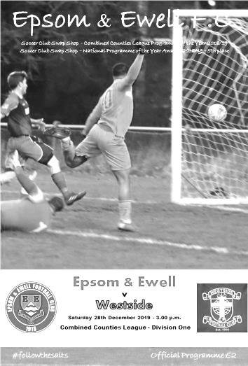
Second half comeback enables Salts to finish the decade on a high note

H.Barber, Ernie Watkins, Johnny Blizzard, Kelvin Gregory, Carl Stewart, Ricky Kidd, Sean Grant, Robbie Burns and now James Fray are members of an elite Epsom club as they have all scored the final goal for our club in a particular decade. However, few if any will have been more impressive than Fray's curling left footed strike from outside the box that set the seal on a fine second half fight back from our boys as we completed a league double over newly promoted Westside, leapfrogging them in the League table in the process.

With Manager Simon Funnell having resigned last week (he would have been suspended for this and the next match anyway, following his sending off against Dorking Wanderers Reserves) and Assistant Sam Morgan away on holiday, former Coach Matt Drew stepped in to help us out in the technical area against a team we had secured a 3-1 win against back in August with a dominant performance. Although the scoring pattern of this match was completely different to the one in August, the match followed a similar pattern as we gradually wore our opponents down over the ninety minutes and a late goal for the visitors made the scoreline closer than I felt it should have been.

But it didn't look like this would be the case at the start. We nearly conceded in the opening twenty-five seconds when a deep left wing cross was headed over our bar from a good position and they took the lead in the eighth minute when a low shot was reached by Conor Young, but he didn't get the sort of contact he had hoped for and at the far post, there was Tevon Webster to tap in the loose ball. The scorer was originally thought to have been Ayman Dahdouh, so I am relying on the Westside Twitter feed for this confirmation!

If I'm honest, even this goal didn't really get us going. The game drifted for a while and it took us until the twentieth minute to fashion a chance, but it was a good one as a ball down the left released James Fray and his low ball across was sidefooted just wide of goal by Lloyd Connelly, playing in the unfamiliar role of centre forward. It was a difficult job for him as the service wasn't the greatest and although he won a number of headers up there, our wide men Rob Hendry and Bobby Bennett were too wide to take advantage of any flick on and the attacks carried little threat. However, there was another great opportunity around the twenty minute mark when Hendry got down the left and delivered a great cross, met by the leaping Bennett, whose header thumped against the Westside crossbar and away to safety.

We were still vulnerable at the back and two minutes later Jahmahl King had to make a fine block as the visitors threatened to extend their lead, but as the half wore on, we gradually

started to get on top and a couple of attempts from Hendry and Scott Murphy were not far off the mark. Indeed we nearly scored the equaliser right on half time when Bennett robbed a defender and drew Albert White in the Westside goal, but he did really well to block Bennett's shot with an outstretched leg and the teams went off with Westside just about preserving their narrow lead.

The second half was much better from an Epsom point of view. Bennett nearly had the ball in the net after Connelly's cheeky backheel put him through, but he suffered a horrible bounce while in the act of shooting and sliced the shot wide from twelve yards. We did have a let off in the 56th minute when a right wing cross left us overloaded two on one at the far post, but under pressure from or defenders the shot was put wide of Young's goal. It would be their last chance for some time.

King was next to try and level matters as he met a deep comer with a volley at goal, although the ball went down into the ground first, which took much of the pace off the shot and White was able to save it. We made a substitution on the hour as Taryn Smith replaced Todd Murphy and Connelly dropping back into the defence and this paid dividends in the 61st minute. Hendry made good ground on the left and squared the ball to Adam Heagney who took a touch from just outside the box and then struck the ball with his supposedly weaker left foot beyond White and in off his right hand post.

Tariq Straker was the next player to get down the left and his dangerous ball fizzed across the goal just a few yards out, but unfortunately just beyond the incoming attackers and shortly after this Hendry delivered a corner from the other side that did exactly the same. But we were well on top now and took the lead in the 70th minute when Straker's run and pass found Smith on the left. His shot across White from fifteen yards was blocked by a foot, but the ball looped high up in the air and Straker, who had continued his run, got there just ahead of the recovering White to nod the ball into an empty net from four yards.

Three minutes later the match was all over as Bennett found Fray just outside the box in a fairly central position and his left footed curler found the top corner from nearly twenty yards to put us 3-1 up. We were good value for this lead now and Hendry was inches wide with a low shot from the left that found the side netting.

We showed that we are still capable of conceding even from the strongest of positions as substitute Szyrus Shokuya beat our offside trap and slotted the ball under the advancing Young in the 85th minute but by the time of the final whistle no one could argue that the three points had gone to the better team on the day.

So where are we at the half way stage of the season? Currently we sit in fifteenth position after climbing two spots at the weekend, but these players are capable of so much more and one of the jobs for the new Manager, whoever they may be, will be to work on the consistency and steer us back into a top half position. Anything else would be a bonus at this stage after a disappointing few months, but second half performances like this are a lot nicer to watch and here's hoping that the new decade brings a lot more of them.

Epsom and Ewell; Conor Young, Tariq Straker, Corey Haywood-Roye, Jahmahl King,
Todd Murphy, Adam Heagney, Bobby Bennett, Scott Murphy (c), Lloyd Connelly,
James Fray, Rob Hendry

Sub: Taryn Smith for T.Murphy (59), Joe Bonass-Ward for Fray (77),
George Smith for Haywood-Roye (84)

British Airways – History
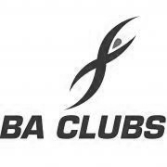
Very little if any early history of the BA football team can be found, except for an entry in the minutes of the initial minutes of the then Speedbird Club where the BA Football team was one of 6 other BA sections that were formed as part of the Sporting and Social Club for BOAC.

So it seems that the earliest date we can verify is April 1947 for the BOAC team, although no such evidence can be found for its counterpart BEA.

What we do know is that the BOAC & BEA teams have played in various local leagues since their inauguration in 1947. As part of a UK Aviation review UK airlines were integrated into one airline British Airways the United Kingdom's national airline, which was created in 1974 with the merger of the two largest UK airlines, British Overseas Airways Corporation (BOAC) and British European Airways (BEA), and including also two smaller regional airlines, Cambrian Airways and Northeast Airlines.

The merger was the completion of a consolidation process started in 1971 with the establishment of the British Airways Board, a body created by the British government to control the operations and finances of BOAC and BEA, which initially continued to exist as separate entities.

It took another 8 years before the teams amalgamated to become one all-encompassing British Airways Football Section, which was driven by the sale of the ‘old’ Silver Wing Club at Northolt to Ameretto’s Country Club and all sporting activities from Northolt moved to the Concorde Centre (formerly Speedbird Club) at Heston. The amalgamation of the two clubs created a huge football section with over 200 members. At that time there were approximately 15 adult teams comprising of BA Staff from office workers to pilots and from baggage handling to IT programmers.

The teams played in local leagues such as the Hanwell and District Midweek League (folded many years ago) this and was followed by the Airport League which has now also folded. The Saturday teams played in the West Middlesex League (that has now also folded) the teams moved to the London Commercial League. This League had ten divisions at one time with at least 10 teams in each division and all the teams had to have their own sports grounds! All this has gone now with companies selling off the land the private developers or deciding that they couldn’t afford to run sporting activities any longer, no wonder we are all getting fatter!

The Football teams at British Airways have had a very long, successful and proud history in Middlesex Junior football winning many league and county honours along the way. The BA Sat 1st team are probably one of the most successful teams in Middlesex Junior football having won the London Commercial League the Division 1 title and Senior League Cup on many occasions. The team has also been successful in the Middlesex County Intermediate Cup winning this cup eight times and in 2005/06/07 this trophy was won 3 years running a feat not equalled (so far)! We have also had success in the Middlesex County Premier Cup winning the trophy in 1997 against a very strong Hayes Reserves XI.

Since moving to the Middlesex County League in 2007 we have won the Premier Division twice and after finishing top of the Premier League we then gained promotion to the Combined Counties League where we finished in tenth place. We remain at Bedfont and Feltham in our ground share arrangement with Brian Barry and his team at the Orchard.

CCL Division One Club Directory
AFC HAYES: Telephone: 0208 845 0110 - Colours: Blue and White Stripes/Blue/Blue
Ground: Farm Park, Kingshill Avenue, Hayes, Middx. UB4 8DD

ASH UNITED: Telephone: 01252 344264 - Colours: Green with Red Trim/Green/Green
Ground: Shawfields Stadium, Youngs Drive, Shawfields Road, Ash, Aldershot. GU12 6RE

BAGSHOT: Telephone: 01252 623804 - Colours: Yellow/Black/Black
Ground: Camberley Town FC – Krooner Park, Wilton Road, Camberley. GU15 2QW

BEDFONT & FELTHAM: Telephone: 0208-890 7264 - Colours: Yellow/Blue/Blue
Ground: The Orchard, Hatton Road, Bedfont. TW14 9QT

BRITISH AIRWAYS: Telephone: 0208-890 7264 - Colours: Sky Blue/Navy Blue/Navy Blue
Ground: Bedfont & Feltham FC - The Orchard, Hatton Road, Bedfont. TW14 9QT

CHESSINGTON & HOOK UNITED: Telephone: 01372-602263 Colours: All Blue
Ground: Chalky Lane, Chessington. KT9 2NF

COVE: Telephone: 01252 543615 Colours: Yellow/Black/Black
Ground: Oak Farm, Squirrel Lane, Cove GU14 8PB

DORKING WANDERERS RES Telephone: 01306 400151 - Colours: Red & White Stripes/ Blue/ Red
Ground: Meadowbank Stadium, Mill Lane, Dorking. RH4 1DX

EPSOM & EWELL Telephone: 01737-553250
Colours: Royal Blue & White Hoops/Royal Blue/Royal Blue
Ground: Chipstead FC, High Road, Chipstead. CR5 3SF

EVERSLEY & CALIFORNIA Telephone: 0118 973 2400 - Colours: - White & Royal Blue Hoops /Royal Blue/ Royal Blue - Ground: Fox Lane, off Reading Road, Eversley. RG27 0NS

FARNHAM TOWN Telephone: 01252 715305 - Colours: - Claret & Sky Blue /White/ Claret & Blue
Ground: Memorial Ground, Babbs Mead, West Street, Farnham. GU9 7DY

FC DEPORTIVO GALICIA Telephone: 0208 831 9067 - Colours: Royal Blue/Royal Blue/White
Ground: Bedfont Sports FC - Bedfont Sports Club, Hatton Road, Bedfont. TW14 9JR

FLEET SPURS Telephone: 01252 662810 - Colours: Dark Blue with Red Trim/Dark Blue/Dark Blue
Ground: Kennels Lane Farnborough. GU14 0ST

GODALMING TOWN Telephone: 01483 417520 - Colours: Yellow/Green/Yellow
Ground: Wey Court, Meadrow, Godalming. GU7 3JE

JERSEY BULLS Telephone: 01534 449615 - Colours: Red and White
Ground: Springfield Stadium, Janvrin Road, St Helier, Jersey. JE2 4LF

KENSINGTON & EALING BOROUGH Telephone: 01372 360151 - Colours: All Blue
Ground: Leatherhead FC – Fetcham Grove, Guildford Road, Leatherhead. KT22 9AS

SANDHURST TOWN Telephone: 01252 878768 - Colours: Red & Black Stripes/Black/Black
Ground: Bottom Meadow, Sandhurst Memorial Park, Yorktown Road, Sandhurst. GU47 9BJ

TOOTING BEC Telephone: tba - Colours: Black & White Stripes/White/White & Black
Ground: Tooting & Mitcham United FC - Imperial Fields, Bishopsford Road, Morden, Surrey SM4 6BF

WALTON & HERSHAM Telephone: 07969 068731 - Colours: All Red
Ground: Elmbridge Excel Sports Hub, Waterside Drive, Walton-on-Thames. KT12 2JP

WESTSIDE Telephone: 01372-602263 - Colours: Yellow/Blue/Blue
Ground: Chessington & Hook United - Chalky Lane, Chessington. KT9 2NF

Centre page for results

Centre page for results

Team of the Decade
Around ten years ago Alex Rodrigues was voted the Player of the Decade for us, following an impressive set of performances. This time out, I thought I’d extend this to a team of the decade.

But where to start? Everyone has their own particular favourite players, but I thought that I have only missed thirteen matches in that entire decade, so if anyone should have the right to put a team together, it is me! If you don’t agree with it, and I’m sure many won’t, then the invitation is there for any supporter to put their own team together and I will add it here in later issues.

I thought the best way to start this would be to summarise all the players who have made at least 50 appearances in this decade and whittle it down from there into a 4-4-2 formation as most people will relate to it better. I have classified players by the position where they played the most.

I should first mention a handful who are not eligible, but in their brief time at the club were memorable and worth a mention in alphabetical order.

James Cottee (27 apps, 11goals) A superb young striker who was brilliant for us in 2013/14.
Tony Cuff (39 apps, 4 goals) A mercurial attacking midfielder during 2010/11 who scored direct from a corner in 2010 against Dorking.
Karl Douglin (44 apps, 14 goals) A very influential midfielder who won the Player of the Year award for 2013/14; a year with many stand out candidates
Jamie Summers (38 apps, 4 goals) A fine defender loaned to us by Kingstonian for a season before moving to play in the US in 2012
Joe White (26 apps, 0 goals) Arguably the best keeper we had in the decade and a member of our League Cup winning team of 2012/13 before moving to play in the US where he remains now.

Now on to the candidates:

Goalkeepers:

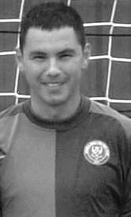
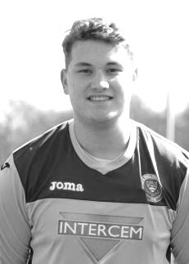
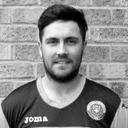
Although coming to the end of his spell at the club by the start of the decade Paul Borg was a reliable and dependable keeper having joined us from Leatherhead in 2007. He played in our opening match of the decade, the Fourth Round FA Vase tie against Long Buckby and made 55 appearances in the decade so he is just eligible for this list.

Kieran Campbell was our next keeper on the list, making 62 appearances, but also scoring two goals in his return a few years later as a striker! Was virtually ever present in our 2013/14 season when we finished third in the Combined Counties League.

In 2014/15 Michael Eacott took over between the posts and big Mike got better and better as his experience increased. Had played against us as a 16 year old for Colliers Wood United and was famously a ball boy at the Wimbledon Men’s singles Final as a teenager!

After three seasons Michael departed with many of the squad in the summer of 2017 and Conor Young took over once his cricket duties allowed. Conor has been involved during our busiest period of the decade and made some wonderful saves in that time, also becoming Player of the Year in 2017/18.

This is a really tough call to open up with but I am going to go for Michael Eacott in my squad.

Defenders:
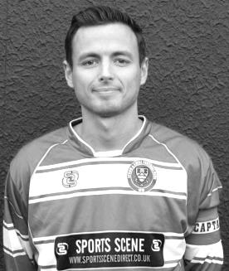
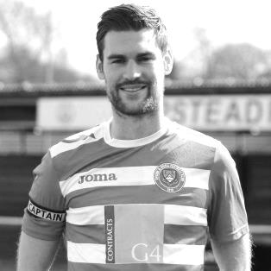
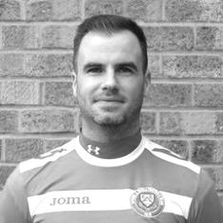
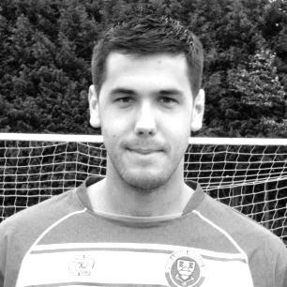
I shall start with a pair of Club Captains Sam Currie and Jamie Hatfield. Jamie joined us in 2006 and was a dependable left back who occasionally got forward to score goals, most notably two stunning long range strikes against Walton & Hersham right back in January 2010. Obviously he will be best remembered for lifting the one competitive trophy we have won since 1981, the League Cup in 2013.

Obviously those at the match will also remember the first goal for the club from Sam as he lashed the ball into the net from a narrow angle to score our third goal in that 3-0 win. Sam played alongside Jamie for a couple of seasons before assuming the Captaincy in 2014/15. Sam made 146 appearances during the decade, while Jamie made 135.

Alongside Sam and indeed inheriting the Captaincy from him was Dan Dean who was ironically a long term target of Lyndon Buckwell’s, yet within six weeks of him joining, Buckwell resigned. That was to Glyn Mandeville’s benefit and he became a dependable player mostly in defence, but also in front of the back four and once, in goal, where he defended two penalties in a match; still the only player to do this for us, as far as I can tell. He was often paired alongside Alex McKay who was also useful in front of goal, scoring 12 times in his 175 appearances this decade, including two in a match against Windsor, with that famous last minute winner.

Back before all of them was an earlier Captain who preceded Hatfield. Alex Rodrigues may have been player of the previous decade but he also made over 100 appearances in this decade and it was a massive loss when he departed for Egham, then Ascot United where he was involved in a great Vase run a few years back.

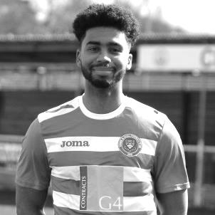
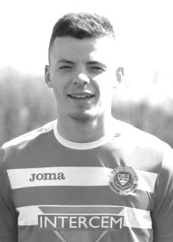
We have had one other great pair of full backs James Taylor and Matt Tanton. Taylor was the son of former defender Dave Taylor and was equally reliable, making 145 appearances over this decade and along with Tanton and Dean before him, members of our 2017 League Cup Final team. Tanton formerly played for our Reserves under Mel Tough briefly in 2013/14 before joining us from Colliers Wood United. Rarely seen individually, they were good mates and when I heard that one was leaving back in 2017, I feared that we’d lose them both and so it proved.

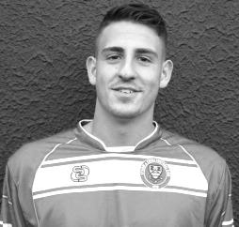
Another who played in that League Cup Final, albeit as a winger, carved a new position as a defender and if there were medals for sheer hard work and tenaciousness, few would be ahead of Reisse Griffin. Reisse has made 144 appearances this decade so far and was one of the few that remained after the player exodus of 2017. He is currently battling a knee injury picked up at Steyning Town in pre-season and I hope we’ll see him back in our colours very soon.

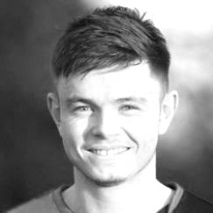
And there have been so many other long serving defenders too. Anthony Panayi came up from our Youth Team and performed extremely well in the early years of the decade, while George Murphy also came in and just edged Panayi out for a starting berth in that League Cup triumph of 2013. Additionally, Craig Hastings and more recently Adam Heagney and Lloyd Connelly have proven to be very dependable players with Hastings now in a key role at Sutton Common Rovers and the latter pair still playing for us, mostly in defence, but not always as Lloyd found out recently when he played centre-forward against Westside to close out the decade!

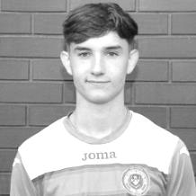
But who makes my team? Well, a League Cup win beats a Final, so I choose Sam Currie and Jamie Hatfield ahead of Taylor and Tanton as full backs with Dan Dean and Alex Rodrigues just getting in ahead of Alex McKay who along with Griffin would make the five man substitutes bench.

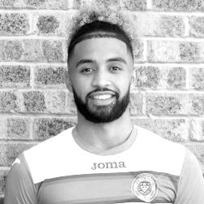
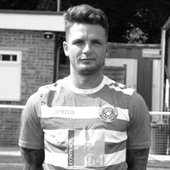
Midfielders:

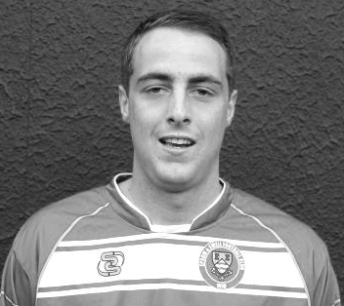
I have decided to play a diamond in this formation as it allows me to choose a specific defensive midfielder, an attacking midfielder and two wider men. Defensively, we have Nathan Ayling who had a brief spell with us before the start of the decade but returned under Glyn Mandeville and became a very good player, going on to play regularly at South Park in the Isthmian League. Another candidate is Carl Downs who we recently saw here as Manager of Dorking Wanderers Reserves, despite still being far too young to have stopped playing. Nathan made exactly 100 appearances for us this decade while Downs made 82.

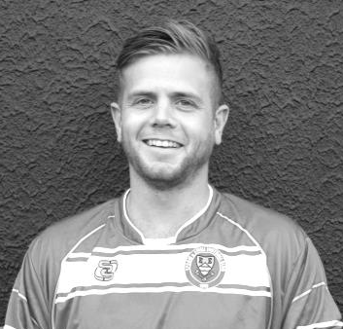
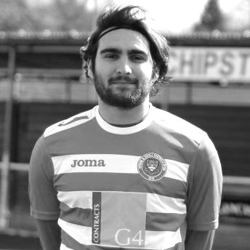
Ben Hayward is also on this list and made 142 appearances during this decade. If anything, Ben’s versatility counts against him as he found himself in a number of positions during his time at the club, although no one can take away that flick over the defender and volley against Molesey in April 2013 which became goal of the season.

As we came through the decade we find Savvas Panayiotou, better known to all as “Agi”. Another in the Griffin mould who had a terrific engine and worked for 90 minutes in every single match, covering much ground. To finish with, we come bang up to date with our current Club Captain Scott Murphy who has been a reliable and constant competitor despite the last few season’s results. Like many others can also play further forward, or indeed further back.

For me though, a defensive midfielder needs coverage skills and so it is Agi Panayiotou that gets the spot.

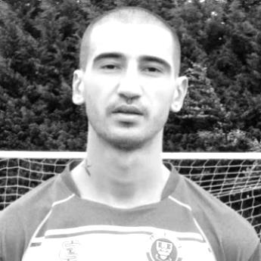
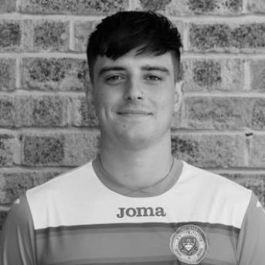
For my two wide players we have an embarrassment of riches at this level with some extremely talented players, and there were few more talented than Ramzi Bedj Bedj, so good they named him twice! Ramzi came from the Ajax Academy I was told, which is quite a background, and the Egyptian showed the sort of skills we have rarely seen at this club in my time. Yet Ramzi won’t make my list, as he occasionally had times where he would drift out of the game. This also goes for a more recent addition to the list Bobby Bennett who can also be devastating when he is on his game as could Jordan Gallagher, a youngster when he joined us in 2016/17 but by the end of that season he was one of the first names on the sheet. A recent underwhelming spell at the club doesn’t detract from his first time here when he made 54 appearances in a debut season, the first to achieve this since 1981. Finally there was Ali Dewar who was extremely fast, but suffered many illnesses and injuries and was never able to get a proper run in the side.

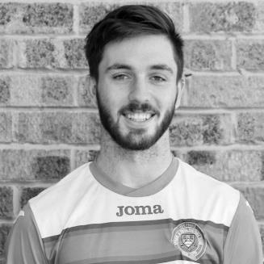
Another who just misses out on the list is mercurial winger Liam Roberts who was extremely exciting to watch, but disciplinary and occasional theatrical falls count against him, even though he has been the victim of some particularly agricultural tackling from a number of defenders and a lack of protection from officials. He would still be in my top eleven players to watch from this decade though.

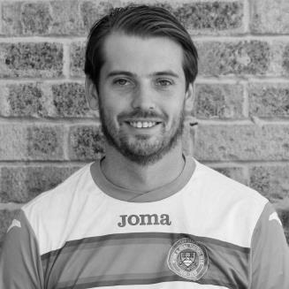
This brings me to the two that make the list. He may have scored over fifty goals but the best left winger we have had at the club this decade is Rob Hendry. Joining in 2015 and scoring on his debut against Windsor, he has been the scorer of some terrific goals for us, but has also found himself out on the wing more often, largely due to other attacking options we may have had. I don’t even know whether Hendo considers this his strongest or even favourite position, but like so many others at our level, they often find themselves moved about because of their versatility.

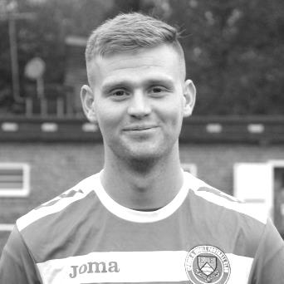
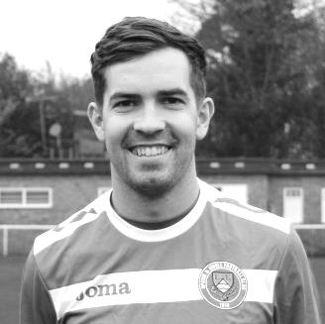
On the other flank to Rob is Matt Ferdinando. A bit of a slow burner to start with as Glyn Mandeville’s first signing as Manager in 2014, he found his way back after injury and became an extremely entertaining player to watch. An instinctive player, some of the things he did on the field were outrageous and along with Bedj Bedj and a player from the nineties, Andy Boxall, these three may make up the most skilful players we ever had on a football field. Completely unplayable at times, he also scored the best goal I have ever seen from an Epsom player with a stunning overhead kick against Farnham Town that was similar, but even more difficult than that famous Wayne Rooney goal against Manchester City. Incredible!

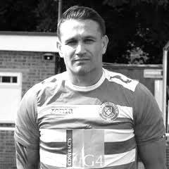
So who plays behind the front two? There are claims for this position from Sam Robinson and Dale Marvell. Robinson joined us back in 2011/12 and starred quite early in a 3-1 win over South Park with two goals. A talented player who was a nice guy off the pitch, it became impossible to refer to him without saying “yeah, but look at the disciplinary record” and regrettably five red cards in just 72 appearances was too many.

Dale Marvell was and remains a club legend. Having made well 337 appearances for the club he sits in ninth position on the all-time list and is also thirteenth on the goal scoring charts with 86. However, “only” 107 of these were this decade and whilst Dale showed incredible longevity and could probably still do a job now despite being in his 40th year, and making my five man bench, I have an even better candidate for the starting position.

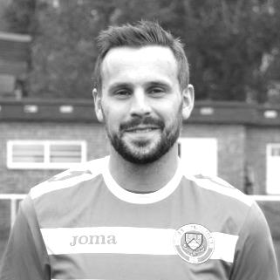
Alex McGregor is another who is deserving of a mention as a reliable and versatile player who had a happy knack of scoring nearly half of his 25 goals for the club (in this decade) from outside the box, with some specials either from the dead ball or in open play. Alex’s father Vic was a regular supporter in his day and the club still presents the Vic McGregor trophy for the Club Person of the Year in his honour, each and every year.

But with all due respect to the other candidates, there is a stand out player here who had the most incredible engine and was capable of scoring a huge number of goals too. Step forward Matt Farrell, who made 141 appearances, scoring 36 goals from the position and covering every blade of ground, often in a defensive role, but more often in an attacking position, he has continued his fine career at Sutton Common Rovers where he is now Club Captain.

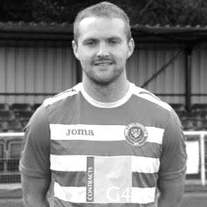
Forwards:

It is impossible to list a team of the decade without naming the player who played most times and scored the most goals in it. Kyle Hough made 245 appearances for our club this decade and scored 153 goals, exactly a hundred more than the next player, Rob Hendry. Kyle joined in 2007/08 and broke records galore, finishing as the third highest scorer in club history. Having only recently passed his 32nd birthday he could still be playing now and it is such a pity that he departed in our relegation season as he would have kept us up, I’m sure.

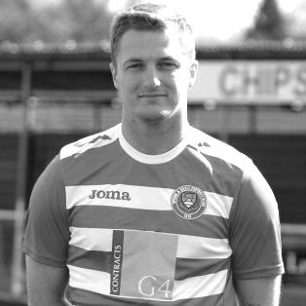
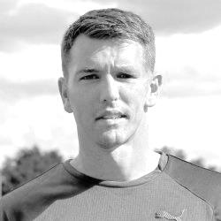
So who plays alongside him? I have three candidates. Daryl Cooper-Smith is an excellent player and registered 52 goals for us in just 80 appearances. Some of his goals were special, but he was equally good as a predator and he didn’t take many penalties either as Hough was on the scene for most of his time at the club. Another with a good case is Mark Jarman, who joined us back in 2009 and despite limited chances at first, still scored 52 goals in 118 appearances this decade. For me though, the best player to play alongside Hough is the man who did just that for a number of years and is the only man to score 37 goals in a season for us (2009/10) since 1984. Robbie Burns gets my vote, with the other pair on the bench.

So here is my final Line-up, and to answer the question on the front page, five players who participated in that League Cup Final win of 2013 are in the starting line-up.

Michael Eacott

Sam Currie Dan Dean Alex Rodrigues Jamie Hatfield (capt)

Savvas ‘Agi’ Panayiotou

Matt Ferdinando Rob Hendry

Matt Farrell

Robbie Burns Kyle Hough

Substitutes,
Alex McKay, Reisse Griffin, Dale Marvell, Daryl Cooper-Smith, Mark Jarman

So that just leaves the Manager, and again this is an easy choice. Lyndon Buckwell was Manager from 2006 until 2014 and was of course in charge when we won the League Cup. His Management team of Glyn Mandeville, Tony Coombe and Russell Banyard would also be there and I would add the one player I haven’t yet mentioned from all of those who made over 50 appearances, Matt Smith, who was a versatile player, but I thought, an innovative Coach, worthy of a place in this team.

And I hope you’ve enjoyed it! This team might have won a few games, don’t you think!

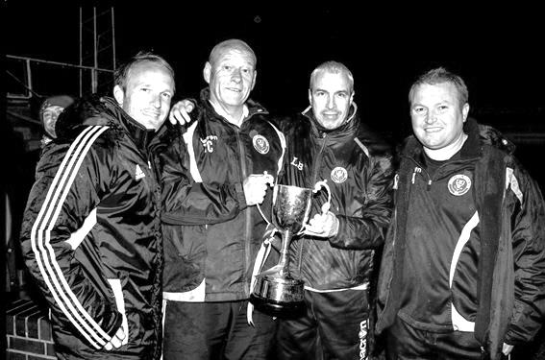

Combined Counties League – Division One
Saturday, 11th January 2020 - Kick-off 3.00 p.m.
Epsom and Ewell  (Royal Blue & White hoops) | V |  | British Airways  (All Yellow)
Squad | NUMBERS |  | Squad
Conor Young |  |  | Jessy Antalika
Steve Betancourt |  |  | Callum Bennet ©
George Smith |  |  | Jordan Bruno
Reisse Griffin |  |  | Bilal Butt
Adam Heagney |  |  | Jordan Haynes
Lloyd Connelly |  |  | Mustafa Khatoun
Jahmahl King |  |  | Jake Morten
Chaz-Lee Martin |  |  | Paul Murphy
Joe Bonass-Ward |  |  | Lewis Nobes
Todd Murphy |  |  | Arinze Nosike
© Scott Murphy |  |  | Peter Parfitt
Corey Haywood-Roye |  |  | Gibson Pasma
Jake Robinson |  |  | Harvey Pasma
James Fray |  |  | Darren Putman
Tariq Straker |  |  | Josh Quadry
Toby Funnell |  |  | Steve Richards
Bobby Bennett |  |  | Charlie Rose
Rob Hendry |  |  | Brad Scott
Taryn Smith |  |  | Dan Shelbourne
Tyrell Hallier-Degale |  |  | Adam Sewell
Sam Morgan | MANAGER |  | Jason Owens
Paul Marshall | ASSISTANTS |  | Rob Pearce
Sam Morgan | COACHES |  | Adam Sewell
Sam Morgan | PHYSIO
REFEREE: R.Albert
ASSISTANTS: I.Hempel, G.Mays

OUR NEXT VISITORS TO HIGH ROAD
Kensington & Ealing Borough
Combined Counties League – Division One
Tuesday, 21st January 2020 – Kick-off – 7.45 p.m.

